Selection Edited from American Yawp

Life in Industrial America
When British author Rudyard Kipling visited Chicago in 1889, he described a city captivated by technology and blinded by greed. He described a rushed and crowded city, a “huge wilderness” with “scores of miles of these terrible streets” and their “hundred thousand of these terrible people.” “The show impressed me with a great horror,” he wrote. “There was no color in the street and no beauty—only a maze of wire ropes overhead and dirty stone flagging under foot.” He took a cab “and the cabman said that these things were the proof of progress.” Kipling visited a “gilded and mirrored” hotel “crammed with people talking about money, and spitting about everywhere.” He visited extravagant churches and spoke with their congregants. “I listened to people who said that the mere fact of spiking down strips of iron to wood, and getting a steam and iron thing to run along them was progress, that the telephone was progress, and the network of wires overhead was progress. They repeated their statements again and again.” Kipling said American newspapers report “that the snarling together of telegraph-wires, the heaving up of houses, and the making of money is progress.”1
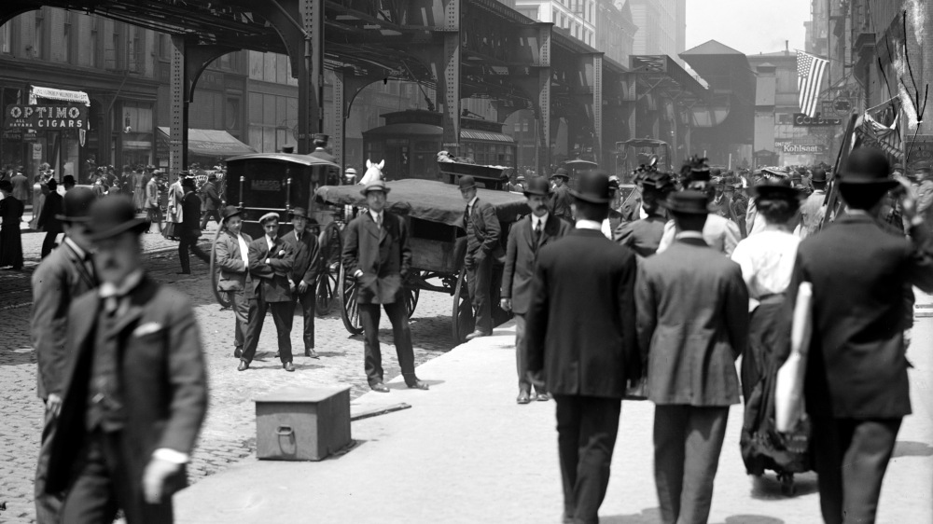
Chicago embodied the triumph of American industrialization. The last decades of the nineteenth century, a new era for big business, saw the formation of large corporations, run by trained bureaucrats and salaried managers, doing national and international business. Chicago, for instance, became America’s butcher. Kipling described in intimate detail the Union Stock Yards, the nation’s largest meat processing zone, a square mile just southwest of the city whose pens and slaughterhouses linked the city’s vast agricultural hinterland to the nation’s dinner tables. “Once having seen them,” he concluded, “you will never forget the sight.” Like other notable Chicago industries, such as agricultural machinery and steel production, the meatpacking industry was closely tied to urbanization and immigration. In 1850, Chicago had a population of about thirty thousand. Twenty years later, it had three hundred thousand. The Great Chicago Fire leveled 3.5 square miles and left a third of its residents homeless in 1871, but the city quickly recovered and resumed its spectacular growth. By the turn of the twentieth century, the city was home to 1.7 million people.
Trending Urban
In 1870, a quarter of the nation’s population lived in towns or cities with populations greater than 2,500. By 1920, a majority did. But if many who flocked to Chicago and other American cities came from rural America, many others emigrated from overseas. Mirroring national immigration patterns, Chicago’s newcomers had at first come mostly from Germany, the British Isles, and Scandinavia, but, by 1890, Eastern and Southern Europeans including Poles, Italians, Czechs, Hungarians, Lithuanians, and Jews made up most new immigrants. Chicago, like many other American industrial cities, was also an immigrant city. In 1900, nearly 80 percent of Chicago’s population was either foreign-born or the children of foreign-born immigrants.2
Kipling visited Chicago just as new industrial modes of production revolutionized the United States. The rise of cities, the evolution of American immigration, the transformation of American labor, the further making of a mass culture, the creation of great concentrated wealth, the growth of vast city slums, the conquest of the West, the emergence of a middle class, the problem of poverty, the triumph of big business, widening inequalities, battles between capital and labor, the final destruction of independent farming, breakthrough technologies, environmental destruction: industrialization created a new America.

Industrialization & Technological Innovation
The railroads created the first great concentrations of capital, spawned the first massive corporations, made the first of the vast fortunes that would define the Gilded Age, unleashed labor demands that united thousands of farmers and immigrants, and linked many towns and cities. National railroad mileage tripled in the twenty years after the outbreak of the Civil War and tripled again over the four decades that followed. Railroads impelled the creation of uniform time zones across the country, gave industrialists access to remote markets, and opened the American West. Railroad companies were the nation’s largest businesses. Their huge expenditures spurred countless industries and attracted droves of laborers. And as they crisscrossed the nation, they created a national market, a truly national economy, and, seemingly, a new national culture.3
The railroads profited from enormous amounts of government support followed. Federal, state, and local governments offered unrivaled handouts to create the national rail networks – making the rich corporations even richer. The wealthy corporations and businessmen used their massive wealth to influence U.S. politicians. The Republican Party—which dominated government policy during the Civil War and Reconstruction—passed legislation granting hundreds of millions of acres of land and millions of dollars’ worth of government bonds to build the great transcontinental railroads. As the gap between rich and poor grew, many people were left behind.
Stronger and more organized labor unions formed to fight for a growing, more-permanent working class. At the same time, the growing scale of economic enterprises increasingly disconnected owners from their employees and day-to-day business operations. To handle their vast new operations, owners turned to managers. Educated bureaucrats swelled the ranks of an emerging middle class.
In September 1878, inventor Thomas Edison announced a new and ambitious line of research and development—electric power and lighting. By late fall 1879, Edison exhibited his system of power generation and electrical light for reporters and investors. By the middle of 1883, Edison had overseen construction of 330 plants powering over sixty thousand lamps in factories, offices, printing houses, hotels, and theaters around the world. He convinced municipal officials to build central power stations and run power lines. New York’s Pearl Street central station opened in September 1882 and powered a square mile of downtown Manhattan. Electricity revolutionized the world. It not only illuminated the night, it powered the Second Industrial Revolution.
Factories could operate anywhere at any hour. Electric rail cars allowed for cities to build out and electric elevators allowed for them to build up. Industry boosted productivity, railroads connected the nation, more and more Americans labored for wages, new bureaucratic occupations created a vast “white collar” middle class, and unprecedented fortunes rewarded the owners of capital. These revolutionary changes, of course, would not occur without conflict or consequence, but they demonstrated the profound transformations remaking the nation. Change was not confined to economics alone. Change gripped the lives of everyday Americans and fundamentally reshaped American culture.6

Immigration and Urbanization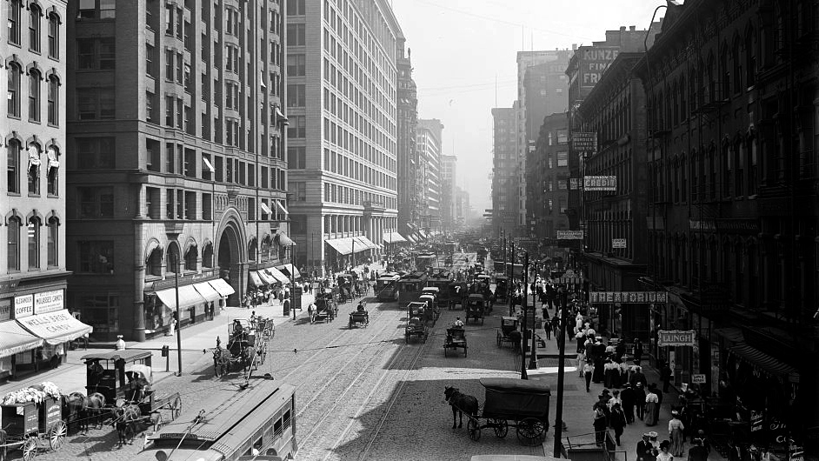
State Street, south from Lake Street, Chicago, Ill, ca.1900-1910. Library of Congress, LC-D4-70158.
Industry pulled ever more Americans into cities. Manufacturing needed the labor pool and the infrastructure. The 1920 U.S. census revealed that, for the first time, a majority of Americans lived in urban areas. Much of that urban growth came from the millions of immigrants pouring into the nation. Between 1870 and 1920, over twenty-five million immigrants arrived in the United States.
By the turn of the twentieth century, new immigrant groups such as Italians, Poles, and Eastern European Jews made up a larger percentage of arrivals than the Irish and Germans. The specific reasons that immigrants left their particular countries and the reasons they came to the United States (what historians call push and pull factors) varied. For example, a young husband and wife living in Sweden in the 1880s and unable to purchase farmland might read an advertisement for inexpensive land in the American Midwest and immigrate to the United States to begin a new life. A young Italian man might simply hope to labor in a steel factory long enough to save up enough money to return home and purchase land for a family. A Russian Jewish family persecuted in European pogroms might look to the United States as a sanctuary. Or perhaps a Japanese migrant might hear of fertile farming land on the West Coast and choose to sail for California. But if many factors pushed people away from their home countries, by far the most important factor drawing immigrants was economics. Immigrants came to the United States looking for work.
Industrial capitalism was the most important factor that drew immigrants to the United States between 1880 and 1920. Immigrant workers labored in large industrial complexes producing goods such as steel, textiles, and food products, replacing smaller and more local workshops. The influx of immigrants, alongside a large movement of Americans from the countryside to the city, helped propel the rapid growth of cities like New York, Pittsburgh, Cleveland, Milwaukee, and St. Louis. By 1890, immigrants and their children accounted for roughly 60 percent of the population in most large northern cities (and sometimes as high as 80 or 90 percent).
Immigrants from specific countries—and often even specific communities—often clustered together in ethnic neighborhoods. They formed vibrant organizations and societies, such as Italian workmen’s clubs, Eastern European Jewish mutual aid societies, and Polish Catholic churches, to ease the transition to their new American home. Immigrant communities published newspapers in dozens of languages and purchased spaces to keep their arts, languages, and traditions alive. And from these foundations they facilitated even more immigration: after staking out a claim to some corner of American life, they wrote home and encouraged others to follow them (historians call this chain migration).
Many cities’ politics adapted to immigrant populations. The infamous urban political machines often operated as a kind of mutual aid society. Tammany Hall’s corruption, especially under the reign of William “Boss” Tweed, was legendary, but the public works projects that funded Tammany Hall’s graft also provided essential infrastructure and public services for the city’s rapidly expanding population. Water, sewer, and gas lines; schools, hospitals, civic buildings, and museums; police and fire departments; roads, parks (notably Central Park), and bridges (notably the Brooklyn Bridge): all could, in whole or in part, be credited to Tammany’s reign.
As the urban population exploded, many immigrants found themselves trapped in crowded, crime-ridden slums. Americans eventually took notice of this urban crisis and proposed municipal reforms but also grew concerned about the declining quality of life in rural areas.
Many longed for a middle path between the cities and the country. New suburban communities on the outskirts of American cities defined themselves in opposition to urban crowding. Americans contemplated the complicated relationships between rural places, suburban living, and urban spaces. Los Angeles became a model for the suburban development of rural places. Dana Barlett, a social reformer in Los Angeles, noted that the city, stretching across dozens of small towns, was “a better city” because of its residential identity as a “city of homes.”10 This language was seized upon by many suburbs that hoped to avoid both urban sprawl and rural decay.11

V. Gender, Religion, and Culture
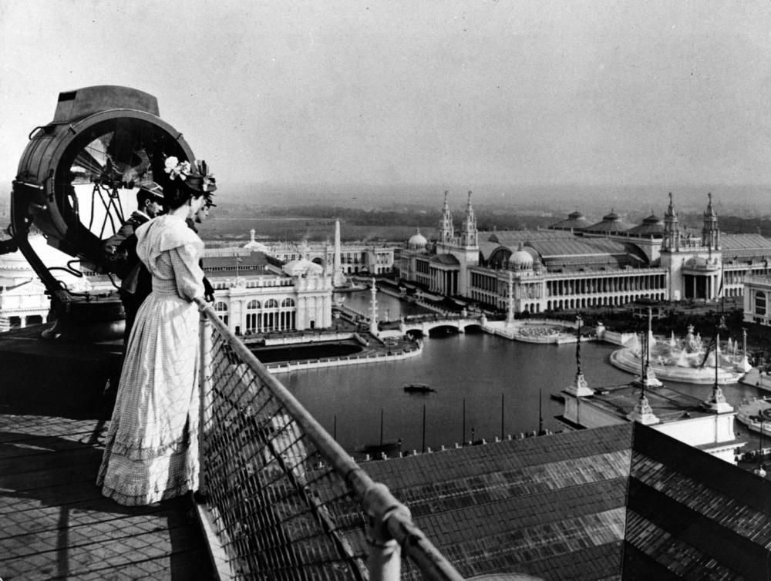
Visitors to the Columbian Exposition of 1893 took in the view of the Court of Honor from the roof of the Manufacturers Building. Art Institute of Chicago, via Wikimedia
The economic and social changes of the late nineteenth and early twentieth centuries—including increased urbanization, immigration, advancements in science and technology, patterns of consumption and the new availability of goods, and new awareness of economic, racial, and gender inequalities—challenged traditional gender norms. At the same time, urban spaces and shifting cultural and social values presented new opportunities to challenge traditional gender and sexual norms. Many women, carrying on a campaign that stretched long into the past, vied for equal rights. They became activists: they targeted municipal reforms, launched labor rights campaigns, and, above all, bolstered the suffrage movement.
Urbanization and immigration fueled anxieties that old social mores were being subverted and that old forms of social and moral policing were increasingly inadequate. The anonymity of urban spaces presented an opportunity in particular for female sexuality and for male and female sexual experimentation along a spectrum of orientations and gender identities. Anxiety over female sexuality reflected generational tensions and differences, as well as racial and class ones. As young women pushed back against social mores through premarital sexual exploration and expression, social welfare experts and moral reformers labeled such girls feeble-minded, believing even that such unfeminine behavior could be symptomatic of clinical insanity rather than free-willed expression. Generational differences exacerbated the social and familial tensions provoked by shifting gender norms. Youths challenged the norms of their parents’ generations by donning new fashions and enjoying the delights of the city. Women’s fashion loosed its physical constraints: corsets relaxed and hemlines rose. The newfound physical freedom enabled by looser dress was also mimicked in the pursuit of other freedoms.
While many women worked to liberate themselves, many, sometimes simultaneously, worked to uplift others. Women’s work against alcohol propelled temperance into one of the foremost moral reforms of the period. Middle-class, typically Protestant women based their assault on alcohol on the basis of their feminine virtue, Christian sentiment, and their protective role in the family and home. Others, like Jane Addams and settlement house workers, sought to impart a middle-class education on immigrant and working-class women through the establishment of settlement homes. Other reformers touted a “scientific motherhood”: the new science of hygiene was deployed as a method of both social uplift and moralizing, particularly of working-class and immigrant women.
Women vocalized new discontents through literature. Charlotte Perkins Gilman’s short story “The Yellow Wallpaper” attacked the “naturalness” of feminine domesticity and critiqued Victorian psychological remedies administered to women, such as the “rest cure.” Kate Chopin’s The Awakening, set in the American South, likewise criticized the domestic and familial role ascribed to women by society and gave expression to feelings of malaise, desperation, and desire. Such literature directly challenged the status quo of constructions of femininity and feminine virtue, as well as established feminine roles.
While many men worried about female activism, they worried too about their own masculinity. To anxious observers, industrial capitalism was hurting American manhood. Rather than working on farms and in factories, where young men formed physical muscle and spiritual grit, new generations of workers labored behind desks, wore white collars, and, in the words of Supreme Court Justice Oliver Wendell Holmes, appeared “black-coated, stiff-jointed, soft-muscled, [and] paste-complexioned.”20 Neurologist George Beard even coined a medical term, neurasthenia, for a new emasculated condition that was marked by depression, indigestion, hypochondria, and extreme nervousness. The philosopher William James called it “Americanitis.” Academics increasingly warned that America had become a nation of emasculated men.
Churches too worried about feminization. Women had always comprised a clear majority of church memberships in the United States, but now the theologian Washington Gladden said, “A preponderance of female influence in the Church or anywhere else in society is unnatural and injurious.” Many feared that the feminized church had feminized Christ himself. Rather than a rough-hewn carpenter, Jesus had been made “mushy” and “sweetly effeminate,” in the words of Walter Rauschenbusch. Advocates of a so-called muscular Christianity sought to stiffen young men’s backbones by putting them back in touch with their primal manliness. Pulling from contemporary developmental theory, they believed that young men ought to evolve as civilization evolved, advancing from primitive nature-dwelling to modern industrial enlightenment. To facilitate “primitive” encounters with nature, muscular Christians founded summer camps and outdoor boys’ clubs like the Woodcraft Indians, the Sons of Daniel Boone, and the Boy Brigades—all precursors of the Boy Scouts. Other champions of muscular Christianity, such as the newly formed Young Men’s Christian Association, built gymnasiums, often attached to churches, where youths could strengthen their bodies as well as their spirits. It was a Young Men’s Christian Association (YMCA) leader who coined the term bodybuilding, and others invented the sports of basketball and volleyball.21
Muscular Christianity, though, was about even more than building strong bodies and minds. Many advocates also ardently championed Western imperialism, cheering on attempts to civilize non-Western peoples. Gilded Age men were encouraged to embrace a particular vision of masculinity connected intimately with the rising tides of nationalism, militarism, and imperialism. Contemporary ideals of American masculinity at the turn of the century developed in concert with the United States’ imperial and militaristic endeavors in the West and abroad. During the Spanish-American War in 1898, Teddy Roosevelt and his Rough Riders embodied the idealized image of the tall, strong, virile, and fit American man that simultaneously epitomized the ideals of power that informed the United States’ imperial agenda. Roosevelt and others like him believed a reinvigorated masculinity would preserve the American race’s superiority against foreign foes and the effeminizing effects of over civilization.

Jacob Riis, How the Other Half Lives (1890)
Jacob Riis, a Danish immigrant, combined photography and journalism into a powerful indictment of poverty in America. His 1890, How the Other Half Lives shocked Americans with its raw depictions of urban slums. Here, he describes poverty in New York.
Long ago it was said that “one half of the world does not know how the other half lives.” That was true then. It did not know because it did not care. The half that was on top cared little for the struggles, and less for the fate of those who were underneath, so long as it was able to hold them there and keep its own seat. There came a time when the discomfort and crowding below were so great, and the consequent upheavals so violent, that it was no longer an easy thing to do, and then the upper half fell to inquiring what was the matter. Information on the subject has been accumulating rapidly since, and the whole world has had its hands full answering for its old ignorance.
In New York … the boundary line of the Other Half lies through the tenements. … To-day three-fourths of its people live in the tenements, and the nineteenth century drift of the population to the cities is sending ever-increasing multitudes to crowd them. The fifteen thousand tenant houses that were the despair of the sanitarian in the past generation have swelled into thirty-seven thousand, and more than twelve hundred thousand persons call them home. The one way out he saw–rapid transit to the suburbs–has brought no relief. We know now that there is no way out; that the “system” that was the evil offspring of public neglect and private greed has come to stay, a storm-centre forever of our civilization. Nothing is left but to make the best of a bad bargain.
What the tenements are and how they grow to what they are, we shall see hereafter. The story is dark enough, drawn from the plain public records, to send a chill to any heart. If it shall appear that the sufferings and the sins of the “other half,” and the evil they breed, are but as a just punishment upon the community that gave it no other choice, it will be because that is the truth. The boundary line lies there because, while the forces for good on one side vastly outweigh the bad–it were not well otherwise–in the tenements all the influences make for evil; because they are the hot-beds of the epidemics that carry death to rich and poor alike; the nurseries of pauperism and crime that fill our jails and police courts; that throw off a scum of forty thousand human wrecks to the island asylums and workhouses year by year; that turned out in the last eight years a round half million beggars to prey upon our charities; that maintain a standing army of ten thousand tramps with all that that implies; because, above all, they touch the family life with deadly moral contagion. This is their worst crime, inseparable from the system. That we have to own it the child of our own wrong does not excuse it, even though it gives it claim upon our utmost patience and tenderest charity.
What are you going to do about it? is the question of to-day. It was asked once of our city in taunting defiance by a band of political cutthroats, the legitimate outgrowth of life on the tenement-house level. Law and order found the answer then and prevailed. With our enormously swelling population held in this galling bondage, will that answer always be given? It will depend on how fully the situation that prompted the challenge is grasped. Forty per cent of the distress among the poor, said a recent official report, is due to drunkenness. But the first legislative committee ever appointed to probe this sore went deeper down and uncovered its roots. The “conclusion forced itself upon it that certain conditions and associations of human life and habitation are the prolific parents of corresponding habits and morals,” and it recommended “the prevention of drunkenness by providing for every man a clean and comfortable home. Years after, a sanitary inquiry brought to light the fact that “more than one-half of the tenements with two-thirds of their population were held by owners veto trade the keeping of them a business, generally a speculation. The owner was seeking a certain percentage on his outlay, and that percentage very rarely fell below fifteen per cent., and frequently exceeded thirty. . . . The complaint was universal among the tenants that they were entirely smeared for, and that the only answer to their requests to have the place put in order by repairs and necessary improvements was that they must pay their rent or leave. The agent’s instructions were simple but emphatic: ‘Collect the rent in advance, or, failing, eject the occupants.”‘ Upon such a stock grew this upas-tree. Small wonder the fruit is bitter. The remedy that shall be an effective answer to the coming appeal for justice must proceed from the public conscience. Neither legislation nor charity can cover the ground. The greed of capital that wrought the evil must itself undo it, as far as it can now be undone. Homes must be built for the working masses by those who employ their labor; but tenements must cease to be “good property” in the old, heartless sense. “Philanthropy and five per cent.” is the penance exacted.
If this is true from a purely economic point of view, what then of the outlook front the Christian standpoint? Not long ago a great meeting was held in this city, of all denominations of religious faith, to discuss the question how to lay hold of these teeming masses in the tenements with Christian influences, to which they are now too often strangers. Might not the conference have found in the warning of one Brooklyn builder, who has invested his capital on this plan and made it pay more than a money interest, a hint worth heeding: “How shall the love of God be understood by those who have been nurtured in sight only of the greed of man?”

