The New South and the Problem of Race
A “New South” seemed an obvious need. The Confederacy’s failed insurrection wreaked havoc on the southern economy and crippled southern prestige. Property was destroyed. Lives were lost. Political power vanished. And four million enslaved Americans—representing the wealth and power of the white South—threw off their chains and walked proudly forward into freedom.
White southerners lashed out, not only in organized terrorist organizations such as the Ku Klux Klan but in political corruption, economic exploitation, and violent intimidation. White southerners took back control of state and local governments and used their reclaimed power to disenfranchise African Americans and pass “Jim Crow” laws segregating schools, transportation, employment, and various public and private facilities. Perhaps nothing harked so forcefully back to the barbaric southern past than the wave of lynchings. Whether for actual crimes, fabricated crimes or for no crimes at all, white mobs murdered roughly five thousand African Americans between the 1880s and the 1950s.
Victims were not simply hanged, they were mutilated, burned alive, and shot. Lynchings could become carnivals, public spectacles attended by thousands of eager spectators. Rail lines ran special cars to accommodate the rush of participants. Vendors sold goods and keepsakes. Perpetrators posed for photos and collected mementos.
At the barbaric height of southern lynching, in the last years of the nineteenth century, southerners lynched two to three African Americans every week. In general, lynchings were most frequent in the Cotton Belt of the Lower South, where southern Black people were most numerous and where the majority worked as tenant farmers and field hands on the cotton farms of white landowners. The states of Mississippi and Georgia had the greatest number of recorded lynchings: from 1880 to 1930.
Throughout the late nineteenth and early twentieth centuries, a number of prominent southerners openly supported lynching. In the late 1890s, Georgia newspaper columnist and noted women’s rights activist Rebecca Latimer Felton—who would later become the first woman to serve in the U.S. Senate—endorsed such extrajudicial killings. She said, “If it takes lynching to protect women’s dearest possession from drunken, ravening beasts, then I say lynch a thousand a week.”14 When opponents argued that lynching violated victims’ constitutional rights, South Carolina governor Coleman Blease angrily responded, “Whenever the Constitution comes between me and the virtue of the white women of South Carolina, I say to hell with the Constitution.”15
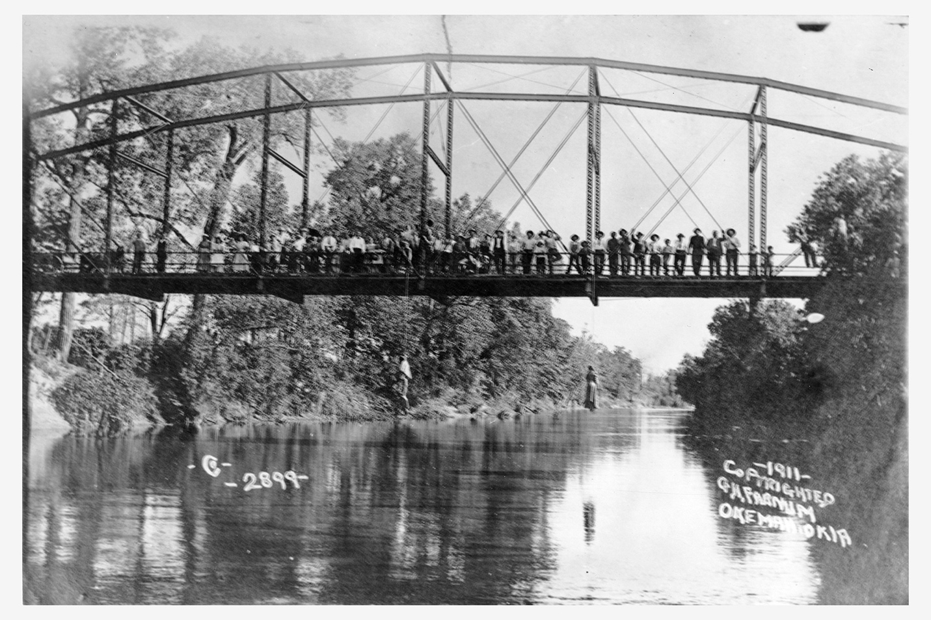
This photograph captures the lynching of Laura and Lawrence Nelson, a mother and son, on May 25, 1911, in Okemah, Oklahoma. In response to national attention, the local white newspaper in Okemah simply wrote, “While the general sentiment is adverse to the method, it is generally thought that the negroes got what would have been due them under due process of law.” Wikimedia.
Black activists and white allies worked to outlaw lynching. Ida B. Wells, an African American woman born in the last years of slavery and a pioneering anti-lynching advocate, lost three friends to a lynch mob in Memphis, Tennessee, in 1892. That year, Wells published Southern Horrors: Lynch Law in All Its Phases, a groundbreaking work that documented the South’s lynching culture and exposed the myth of the Black rapist.16 The Tuskegee Institute and the NAACP both compiled and publicized lists of every reported lynching in the United States. In 1918, Representative Leonidas Dyer of Missouri introduced federal anti-lynching legislation that would have made local counties where lynchings took place legally liable for such killings. Throughout the early 1920s, the Dyer Bill was the subject of heated political debate, but, fiercely opposed by southern congressmen and unable to win enough northern champions, the proposed bill was finally enacted in 2022.
Lynching was not only the form of racial violence that survived Reconstruction. In North Carolina, Populists and Republicans “fused” together and won stunning electoral gains in 1896. Shocked White Democrats, which a generation earlier was the pro-slavery party, formed “Red Shirt” groups, terrorist organizations dedicated to eradicating black political participation and restoring White Supremacy through violence and intimidation. Launching a self-described “white supremacy campaign” of violence, murder and intimidation against black voters and officeholders during the 1898 state elections, the Red Shirts effectively took back state government. But municipal elections were not held that year in Wilmington, where black and white Fusionists controlled city government. After manning armed barricades blocking black voters from entering the town to vote in the state elections, the Red Shirts drafted a “White Declaration of Independence” which declared “that that we will no longer be ruled and will never again be ruled, by men of African origin.” 457 white Democrats signed the document. They also issued a twelve-hour ultimatum that editor of the city’s black daily paper flee the city. The editor left, but it wasn’t enough. Twelve hours later, hundreds of white supremacist Red Shirts raided the city’s armory and ransacked the newspaper office anyway. The mob swelled and turned on the city’s black neighborhood, destroying homes and businesses and opening fire on any Black person they found. Dozens were killed and hundreds more fled the city. The mob then forced the mayor, the city’s aldermen, and the police chief, at gun point, to immediately resign. To ensure their gains, the Democrats rounded up prominent fusionists, placed them on railroad cars, and, under armed guard, sent them out of the state. The mob installed and swore in their own replacements. It was a full-blown coup, an overthrow of the rightful government.
Lynching and organized terror campaigns were only the violent worst of the South’s racial world. Discrimination in employment and housing and the legal segregation of public and private life also reflected the rise of a new Jim Crow South. So-called Jim Crow laws legalized what custom had long dictated. Southern states and municipalities enforced racial segregation in public places and in private lives. Separate coach laws were some of the first such laws to appear, beginning in Tennessee in the 1880s. Soon schools, stores, theaters, restaurants, bathrooms, and nearly every other part of public life were segregated. So too were social lives. The sin of racial mixing, critics said, had to be heavily guarded against. Marriage laws regulated against interracial couples, and white men, ever anxious of relationships between Black men and white women, passed miscegenation laws and justified lynching as an appropriate extralegal tool to police the racial divide.
Whites stuffed ballot boxes and intimidated Black voters with physical and economic threats. And then, from roughly 1890 to 1908, southern states “legal” disfranchisement. They passed laws requiring voters to pass literacy tests (which could be judged arbitrarily) and pay poll taxes (which hit poor white and poor Black Americans alike), effectively denying Black men the right to vote that was supposed to have been guaranteed by the Constitution in the Fifteenth Amendment (1870). Those responsible for such laws posed as reformers and justified voting restrictions as for the public good, a way to clean up politics.
White southerners looked forward while simultaneously harking back to a mythic imagined past inhabited by contented and loyal slaves, benevolent and generous masters, chivalric and honorable men, and pure and faithful southern belles. Secession, they said, had little to do with the institution of slavery, and soldiers fought only for home and honor, not the continued ownership of human beings. Lost Cause champions overtook the South. Women’s groups, such as the United Daughters of the Confederacy, joined with Confederate veterans to preserve a pro-Confederate past. They built Confederate monuments and celebrated Confederate veterans on Memorial Day. Across the South, towns erected statues of General Robert E. Lee and other Confederate figures. By the turn of the twentieth century, the idealized Lost Cause past was entrenched not only in the South but across the country. In 1905, for instance, North Carolinian Thomas F. Dixon published a novel, The Clansman, which depicted the Ku Klux Klan as heroic defenders of the South against the corruption of African American and northern misrule during Reconstruction. In 1915, acclaimed film director David W. Griffith adapted Dixon’s novel into the groundbreaking blockbuster film, Birth of a Nation. (The film almost singlehandedly rejuvenated the Ku Klux Klan.) The romanticized version of the antebellum South and the distorted version of Reconstruction dominated popular imagination.17
In most cases, as in most aspects of life in the New South, new factory jobs were racially segregated. Better-paying jobs were reserved for whites, while the most dangerous, labor-intensive, dirtiest, and lowest-paying positions were relegated to African Americans. African American women, shut out of most industries, found employment most often as domestic help for white families. As poor as white southern mill workers were, southern Black people were poorer. Some white mill workers could even afford to pay for domestic help in caring for young children, cleaning houses, doing laundry, and cooking meals. Mill villages that grew up alongside factories were whites-only, and African American families were pushed to the outer perimeter of the settlements. Industrial development and expanding infrastructure, rather than re-creating the South, coexisted easily with white supremacy and an impoverished agricultural economy. The trains came, factories were built, and capital was invested, but the region remained mired in poverty and racial apartheid. Much of the “New South,” then, was anything but new.
World War I

World War I (“The Great War”) toppled empires, created new nations, and sparked tensions that would explode across future years. On the battlefield, gruesome modern weaponry wrecked an entire generation of young men. The United States entered the conflict in 1917 and was never again the same. The war heralded to the world the United States’ potential as a global military power, and, domestically, it advanced but then beat back American racial & economic justice movements by unleashing vicious waves of repression. Finally, it laid the groundwork for a global depression, a second world war, and an entire history of national, religious, and cultural conflict around the globe.
By the end of the war, more than 4.7 million American men had served in all branches of the military: four million in the army, six hundred thousand in the navy, and about eighty thousand in the Marine Corps. The United States lost over one hundred thousand men (fifty-three thousand died in battle, and even more from disease). Their terrible sacrifice, however, paled before the Europeans’. After four years of brutal stalemate, France had suffered almost a million and a half military dead and Germany even more. Both nations lost about 4 percent of their population to the war. And death was not done.19
Who Can Serve?
Prevailing racial attitudes among white Americans mandated the assignment of white and Black soldiers to different units. Despite racial discrimination, many Black American leaders, such as New York City resident W. E. B. Du Bois, supported the war effort and sought a place at the front for Black soldiers. Black leaders viewed military service as an opportunity to demonstrate to white society the willingness and ability of Black men to assume all duties and responsibilities of citizens, including wartime sacrifice. If Black soldiers were drafted and fought and died on equal footing with white soldiers, then white Americans would see that they deserved full citizenship. The War Department, however, barred Black troops from combat and relegated Black soldiers to segregated service units where they worked as general laborers.
The army also attempted to restrict the privileges of Black soldiers to ensure that the conditions they encountered in Europe did not lead them to question their place in American society. In France, however, the experiences of Black soldiers during training and periods of leave, coupled with their service, proved transformative. While restricted from serving in U.S. combats unit thousands of African-Americans served with distinction as part of the French army during the conflict.
Women reacted to the war preparations by joining several military and civilian organizations. Their enrollment and actions in these organizations proved to be a pioneering effort for American women in war. Military leaders authorized the permanent gender transition of several occupations that gave women opportunities to don uniforms where none had existed before in history. Civilian wartime organizations, although chaired by male members of the business elite, boasted all-female volunteer workforces. Women performed the bulk of volunteer work during the war.11 Army women served as telephone operators (Hello Girls) for the Signal Corps, navy women enlisted as yeomen (clerical workers), and the first groups of women joined the Marine Corps in July 1918. Approximately twenty-five thousand nurses served in the Army and Navy Nurse Corps for duty stateside and overseas, and about a hundred female physicians were contracted by the army. Neither the female nurses nor the doctors served as commissioned officers in the military, leaving the status of professional medical women hovering somewhere between the enlisted and officer ranks. As a result, many female nurses and doctors suffered various physical and mental abuses at the hands of their male coworkers with no system of redress in place.12
Jim Crow segregation in both the military and the civilian sector stood as a barrier for Black women who wanted to give their time to the war effort. The military prohibited Black women from serving as enlisted or appointed medical personnel. The only avenue for Black women to wear a military uniform existed with the armies of the allied nations. A few Black female doctors and nurses joined the French Foreign Legion to escape the racism in the American army. Black female volunteers faced the same discrimination in civilian wartime organizations. White leaders of the American Red Cross, YMCA/YWCA, and Salvation Army municipal chapters refused to admit Black women as equal participants. Black women were forced to charter auxiliary units as subsidiary divisions and were given little guidance on organizing volunteers. They turned instead to the community for support and recruited millions of women for auxiliaries that supported the nearly two hundred thousand Black soldiers and sailors serving in the military. While most female volunteers labored to care for Black families on the home front, three YMCA secretaries worked with the Black troops in France.14
The Aftermath of WWI

At home, the United States grappled with harsh postwar realities. Racial tensions culminated in the Red Summer of 1919 when violence broke out in at least twenty-five cities, including Chicago and Washington, D.C. The riots originated from wartime racial tensions. Industrial war production and massive wartime service created vast labor shortages, and thousands of Black southerners traveled to the North and Midwest to escape the traps of southern poverty. But the so-called Great Migration sparked significant racial conflict as white northerners and returning veterans fought to reclaim their jobs and their neighborhoods from new Black migrants.28

Many Black Americans, who had fled the Jim Crow South and traveled halfway around the world to fight for the United States, would not so easily accept postwar racism. The overseas experience of Black Americans and their return triggered a dramatic change in Black communities. W. E. B. Du Bois wrote boldly of returning soldiers: “We return. We return from fighting. We return fighting. Make way for Democracy!”29 But white Americans desired a return to the status quo, a world that did not include social, political, or economic equality for Black people.
In 1919, America suffered through the “Red Summer.” Riots erupted across the country from April until October. The massive bloodshed included thousands of injuries, hundreds of deaths, and vast destruction of private and public property across the nation. The Chicago Riot, from July 27 to August 3, 1919, considered the summer’s worst, sparked a week of mob violence, murder, and arson. Race riots had rocked the nation before, but the Red Summer was something new. Recently empowered Black Americans actively defended their families and homes from hostile white rioters, often with militant force. This behavior galvanized many in Black communities, but it also shocked white Americans who alternatively interpreted Black resistance as a desire for total revolution or as a new positive step in the path toward Black civil rights. In the riots’ aftermath, James Weldon Johnson wrote, “Can’t they understand that the more Negroes they outrage, the more determined the whole race becomes to secure the full rights and privileges of freemen?” Those six hot months in 1919 forever altered American society and roused and terrified those that experienced the sudden and devastating outbreaks of violence.30

“The New Negro”

The iniquities of Jim Crow segregation, the barbarities of America’s lynching epidemic, and the depravities of 1919’s Red Summer weighed heavily upon Black Americans as they entered the 1920s. The injustices and the violence continued. In Tulsa, Oklahoma, Black Americans had built up the Greenwood District with commerce and prosperity. Booker T. Washington called it the “Black Wall Street.” On the evening of May 31, 1921, spurred by a false claim of sexual assault levied against a young Black man–nineteen-year-old Dick Rowland had likely either tripped over a young white elevator operator’s foot or tripped and brushed the woman’s shoulder with his hand–a white mob mobilized, armed themselves, and destroyed the prosperous neighborhood. Over thirty square blocks were destroyed. Mobs burned over 1,000 homes and killed as many as several hundred Black Tulsans. Survivors recalled the mob using heavy machine guns, and others reported planes circling overhead, firing rifles, and dropping firebombs. When order was finally restored the next day, the bodies of the victims were buried in mass graves. Thousands of survivors were left homeless.
The relentlessness of racial violence awoke a new generation of Black Americans to new alternatives. The Great Migration had pulled enormous numbers of Black southerners northward, and, just as cultural limits loosened across the nation, the 1920s represented a period of self-reflection among African Americans, especially those in northern cities. New York City was a popular destination of Black Americans during the Great Migration. The city’s Black population grew 257 percent, from 91,709 in 1910 to 327,706 by 1930 (the white population grew only 20 percent).22Moreover, by 1930, some 98,620 foreign-born Black people had migrated to the United States. Nearly half made their home in Manhattan’s Harlem district.23 Continuous relocation to “the greatest Negro City in the world” exacerbated problems with crime, health, housing, and unemployment.24 Nevertheless, it brought together a mass of Black people energized by race pride, military service in World War I, the urban environment, and, for many, ideas of Pan-Africanism or Garveyism. James Weldon Johnson called Harlem “the Culture Capital.”25 The area’s cultural ferment produced the Harlem Renaissance and fostered what was then termed the New Negro Movement.
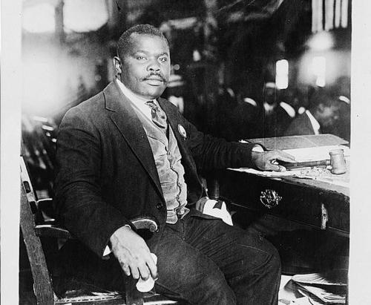
The explosion of African American self-expression found multiple outlets in politics. In the 1910s and 1920s, perhaps no one so attracted disaffected Black activists as Marcus Garvey. Garvey was a Jamaican publisher and labor organizer who arrived in New York City in 1916. Within just a few years of his arrival, he built the largest Black nationalist organization in the world, the Universal Negro Improvement Association (UNIA).29 Inspired by Pan-Africanism and Booker T. Washington’s model of industrial education, and critical of what he saw as Du Bois’s elitist strategies in service of Black elites, Garvey sought to promote racial pride, encourage Black economic independence, and root out racial oppression in Africa and the Diaspora.30
Headquartered in Harlem, the UNIA published a newspaper, Negro World, and organized elaborate parades in which members, known as Garveyites, dressed in ornate, militaristic regalia and marched down city streets. The organization criticized the slow pace of the judicial focus of the NAACP as well as its acceptance of memberships and funds from whites. “For the Negro to depend on the ballot and his industrial progress alone,” Garvey opined, “will be hopeless as it does not help him when he is lynched, burned, jim-crowed, and segregated.” In 1919, the UNIA announced plans to develop a shipping company called the Black Star Line as part of a plan that pushed for Black Americans to reject the political system and to “return to Africa” instead. Most of the investments came in the form of shares purchased by UNIA members, many of whom heard Garvey give rousing speeches across the country about the importance of establishing commercial ventures between African Americans, Afro-Caribbeans, and Africans.31
Garvey’s detractors disparaged these public displays and poorly managed business ventures, and they criticized Garvey for peddling empty gestures in place of measures that addressed the material concerns of African Americans. NAACP leaders depicted Garvey’s plan as one that simply said, “Give up! Surrender! The struggle is useless.” Government officials and their conservative allies launched the “Garvey Must Go” campaign, which culminated in his 1922 indictment and 1925 imprisonment and subsequent deportation for “using the mails for fraudulent purposes.” The UNIA never recovered its popularity or financial support, even after Garvey’s pardon in 1927, but his movement made a lasting impact on Black consciousness in the United States and abroad. He inspired the likes of Malcolm X, whose parents were Garveyites, and Kwame Nkrumah, the first president of Ghana. Garvey’s message, perhaps best captured by his rallying cry, “Up, you mighty race,” resonated with African Americans who found in Garveyism a dignity not granted them in their everyday lives. In that sense, it was all too typical of the Harlem Renaissance.32

The Great Depression

Hard times had hit the United States before, but never had an economic crisis lasted so long or inflicted as much harm as the slump that followed the 1929 crash. After nearly a decade of supposed prosperity, the economy crashed to a halt. People suddenly stopped borrowing and buying. Industries built on debt-fueled purchases sold fewer goods. Retailers lowered prices and, when that did not attract enough buyers to turn profits, they laid off workers to lower labor costs. With so many people out of work and without income, shops sold even less, dropped their prices lower still, and then shed still more workers, creating a vicious downward cycle.
Four years after the crash, the Great Depression reached its lowest point: nearly one in four Americans who wanted a job could not find one and, of those who could, more than half had to settle for part-time work. Farmers could not make enough money from their crops to make harvesting worthwhile. Food rotted in the fields of a starving nation.

The Origins of the Great Depression
On Thursday, October 24, 1929, stock market prices suddenly plummeted. Ten billion dollars in investments (roughly equivalent to about $100 billion today) disappeared in a matter of hours. Panicked selling set in, stock values sank to sudden lows, and stunned investors crowded the New York Stock Exchange demanding answers. On October 29, Black Tuesday, the stock market began its long precipitous fall. Stock values evaporated. Shares of U.S. Steel dropped from $262 to $22. General Motors stock fell from $73 a share to $8. Four fifths of J. D. Rockefeller’s fortune—the greatest in American history—vanished.
Although the crash stunned the nation, it exposed the deeper, underlying problems with the American economy in the 1920s. The stock market’s popularity grew throughout the decade, but only 2.5 percent of Americans had brokerage accounts; the overwhelming majority of Americans had no direct personal stake in Wall Street. The stock market’s collapse, no matter how dramatic, did not by itself depress the American economy. Instead, the crash exposed a great number of factors that, when combined with the financial panic, sank the American economy into the greatest of all economic crises. Rising inequality, declining demand, rural collapse, overextended investors, and the bursting of speculative bubbles all conspired to plunge the nation into the Great Depression.
Despite resistance by Progressives, the vast gap between rich and poor accelerated throughout the early twentieth century. In the aggregate, Americans were better off in 1929 than in 1920. Per capita income had risen 10 percent for all Americans, but 75 percent for the nation’s wealthiest citizens.1
The pro-business policies of the 1920s were designed for an American economy built on the production and consumption of durable goods. More and more, the well-to-do had no need for the new automobiles, radios, and other consumer goods that fueled gross domestic product (GDP) growth in the 1920s. When products failed to sell, goods piled up, factories scaled back production, and companies fired workers, stripping potential consumers of cash, blunting demand for consumer goods, and replicating the downward economic cycle. The situation was only made worse because machines had for decades replaced workers leading to more goods and fewer people who could afford them.2
For American farmers, meanwhile, hard times began long before the markets crashed. In 1920 and 1921, after several years of larger-than-average profits, farm prices in the South and West continued their long decline, plummeting as production climbed and domestic and international demand for cotton, foodstuffs, and other agricultural products stalled. Widespread soil exhaustion on western farms only worsened the problem. Farmers found themselves unable to make payments on loans taken out during the good years, and banks in agricultural areas tightened credit in response. By 1929, farm families were overextended, in no shape to make up for declining consumption, and in a precarious economic position even before the Depression wrecked the global economy.3
But beyond structural flaws, speculative bubbles, and destructive protectionism, the final contributing element of the Great Depression was panic. The frantic reaction to the market’s fall aggravated the economy’s other many failings. More economic policies backfired. The Federal Reserve overcorrected in their response to speculation by raising interest rates and tightening credit. Across the country, banks denied loans and called in debts. Their patrons, afraid that reactionary policies meant further financial trouble, rushed to withdraw money before institutions could close their doors, ensuring their fate. Such bank runs were not uncommon in the 1920s, but in 1930, with the economy worsening and panic from the crash accelerating, 1,352 banks failed. In 1932, nearly 2,300 banks collapsed, taking personal deposits, savings, and credit with them.6
The Great Depression was the confluence of many problems, most of which had begun during a time of unprecedented economic growth. Fiscal policies of the Republican “business presidents” undoubtedly widened the gap between rich and poor and fostered a standoff over international trade, but such policies were widely popular and, for much of the decade, widely seen as a source of the decade’s explosive growth. With fortunes to be won and standards of living to maintain, few Americans had the foresight or wherewithal to repudiate an age of easy credit, rampant consumerism, and wild speculation. Instead, as the Depression worked its way across the United States, Americans hoped to weather the economic storm as best they could, hoping for some relief from the ever-mounting economic collapse that was strangling so many lives.

The Lived Experience of the Great Depression
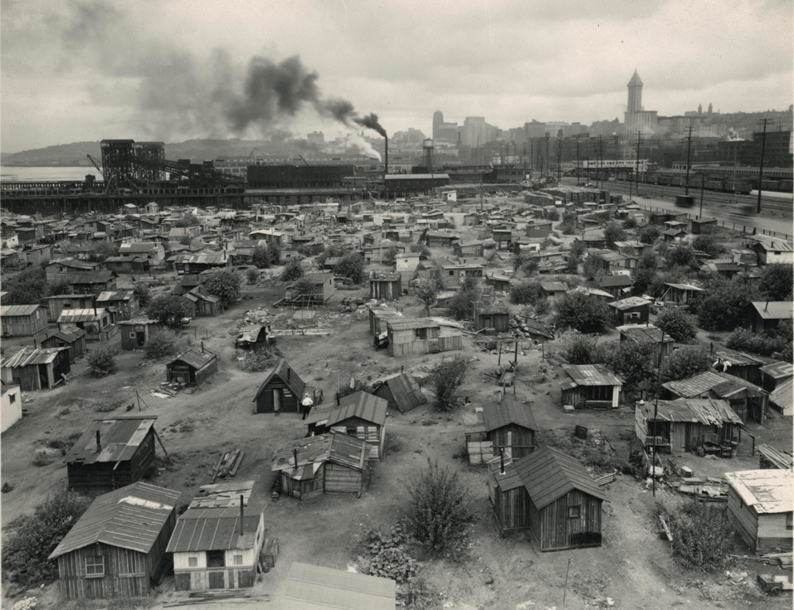

In 1934 a woman from Humboldt County, California, wrote to First Lady Eleanor Roosevelt seeking a job for her husband, a surveyor, who had been out of work for nearly two years. The pair had survived on the meager income she received from working at the county courthouse. “My salary could keep us going,” she explained, “but—I am to have a baby.” The family needed temporary help, and, she explained, “after that I can go back to work and we can work out our own salvation. But to have this baby come to a home full of worry and despair, with no money for the things it needs, is not fair. It needs and deserves a happy start in life.”16
As the United States slid ever deeper into the Great Depression, such tragic scenes played out time and time again. Individuals, families, and communities faced the painful, frightening, and often bewildering collapse of the economic institutions on which they depended. The more fortunate were spared the worst effects, and a few even profited from it, but by the end of 1932, the crisis had become so deep and so widespread that most Americans had suffered directly. Markets crashed through no fault of their own. Workers were plunged into poverty because of impersonal forces for which they shared no responsibility.
With rampant unemployment and declining wages, Americans slashed expenses. The fortunate could survive by simply deferring vacations and regular consumer purchases. Middle- and working-class Americans might rely on disappearing credit at neighborhood stores, default on utility bills, or skip meals. Those who could borrowed from relatives or took in boarders in homes or “doubled up” in tenements. But such resources couldn’t withstand the unending relentlessness of the economic crisis. As one New York City official explained in 1932,
When the breadwinner is out of a job he usually exhausts his savings if he has any.… He borrows from his friends and from his relatives until they can stand the burden no longer. He gets credit from the corner grocery store and the butcher shop, and the landlord forgoes collecting the rent until interest and taxes have to be paid and something has to be done. All of these resources are finally exhausted over a period of time, and it becomes necessary for these people, who have never before been in want, to go on assistance.17
But public assistance and private charities were quickly exhausted by the scope of the crisis. As one Detroit city official put it in 1932,
Many essential public services have been reduced beyond the minimum point absolutely essential to the health and safety of the city.… The salaries of city employees have been twice reduced … and hundreds of faithful employees … have been furloughed. Thus has the city borrowed from its own future welfare to keep its unemployed on the barest subsistence levels.… A wage work plan which had supported 11,000 families collapsed last month because the city was unable to find funds to pay these unemployed—men who wished to earn their own support. For the coming year, Detroit can see no possibility of preventing wide-spread hunger and slow starvation through its own unaided resources.18
These most desperate Americans, the chronically unemployed, encamped on public or marginal lands in “Hoovervilles,” spontaneous shantytowns that dotted America’s cities, depending on bread lines and street-corner peddling. One doctor recalled that “every day … someone would faint on a streetcar. They’d bring him in, and they wouldn’t ask any questions.… they knew what it was. Hunger.”19
Making a New Deal: Industrial Workers in Chicago, 1919–1939 (New York: Cambridge University Press, 1990), chap. 5).)) “A man is not a man without work,” one of the jobless told an interviewer.20 The ideal of the “male breadwinner” was always a fiction for poor Americans, and, during the crisis, women and young children entered the labor force, as they always had. But, in such a labor crisis, many employers, subscribing to traditional notions of male bread-winning, were less likely to hire married women and more likely to dismiss those they already employed.21 As one politician remarked at the time, the woman worker was “the first orphan in the storm.”22
American suppositions about family structure meant that women suffered disproportionately from the Depression. Since the start of the twentieth century, single women had become an increasing share of the workforce, but married women, Americans were likely to believe, took a job because they wanted to and not because they needed it. Once the Depression came, employers were therefore less likely to hire married women and more likely to dismiss those they already employed.23 Women on their own and without regular work suffered a greater threat of sexual violence than their male counterparts; accounts of such women suggest they depended on each other for protection24
The Great Depression was particularly tough for nonwhite Americans. “The Negro was born in depression,” one Black pensioner told interviewer Studs Terkel. “It didn’t mean too much to him. The Great American Depression . . . only became official when it hit the white man.” ((Studs Terkel, Hard Times: An Oral History of the Great Depression (New York: Pantheon Books, 1970), 81-82.)) Black workers were generally the last hired when businesses expanded production and the first fired when businesses experienced downturns. As a National Urban League study found, “So general is this practice that one is warranted in suspecting that it has been adopted as a method of relieving unemployment of whites without regard to the consequences upon Negroes.”25 In 1932, with the national unemployment average hovering around 25 percent, Black unemployment reached as high as 50 percent, while even Black workers who kept their jobs saw their already low wages cut dramatically.26

V. Migration and the Great Depression
On the Great Plains, environmental catastrophe deepened America’s longstanding agricultural crisis and magnified the tragedy of the Depression. Beginning in 1932, severe droughts hit from Texas to the Dakotas and lasted until at least 1936. The droughts compounded years of agricultural mismanagement. To grow their crops, Plains farmers had plowed up natural ground cover that had taken ages to form over the surface of the dry Plains states. Relatively wet decades had protected them, but, during the early 1930s, without rain, the exposed fertile topsoil turned to dust, and without sod or windbreaks such as trees, rolling winds churned the dust into massive storms that blotted out the sky, choked settlers and livestock, and rained dirt not only across the region but as far east as Washington, D.C., New England, and ships on the Atlantic Ocean. The Dust Bowl, as the region became known, exposed all-too-late the need for conservation. The region’s farmers, already hit by years of foreclosures and declining food and crop prices, were decimated.27 For many in Texas, Oklahoma, Kansas, and Arkansas who were “baked out, blown out, and broke,” their only hope was to travel west to California, whose rains still brought bountiful harvests and—potentially—jobs for farmworkers. It was an exodus. Oklahoma lost 440,000 people, or a full 18.4 percent of its 1930 population, to outmigration.28
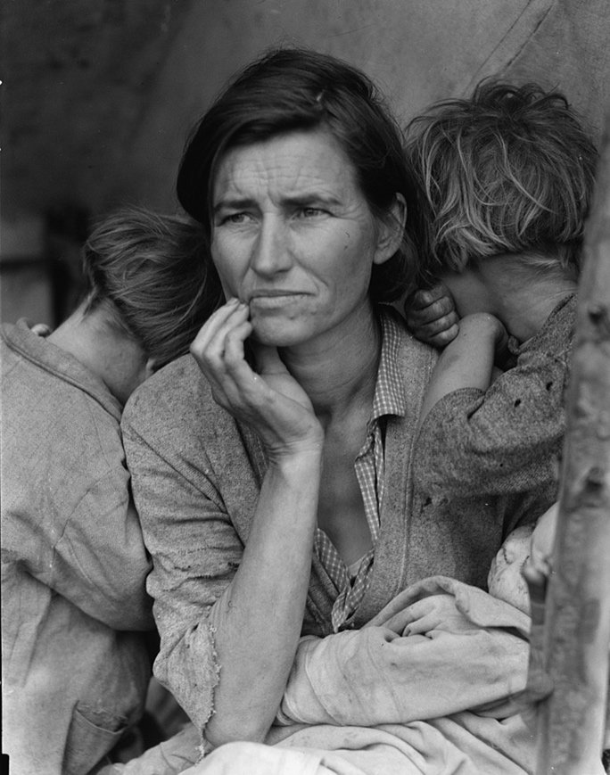
Dorothea Lange’s Migrant Mother became one of the most enduring images of the Dust Bowl and the ensuing westward exodus. Lange, a photographer for the Farm Security Administration, captured the image at a migrant farmworker camp in Nipomo, California, in 1936. In the photograph a young mother stares out with a worried, weary expression. She was a migrant, having left her home in Oklahoma to follow the crops to the Golden State. She took part in what many in the mid-1930s were beginning to recognize as a vast migration of families out of the southwestern Plains states. In the image she cradles an infant and supports two older children, who cling to her. Lange’s photo encapsulated the nation’s struggle. The subject of the photograph seemed used to hard work but down on her luck, and uncertain about what the future might hold.
These years witnessed the first significant reversal in the flow of people between rural and urban areas. Thousands of city dwellers fled the jobless cities and moved to the country looking for work. As relief efforts floundered, many state and local officials threw up barriers to migration, making it difficult for newcomers to receive relief or find work. Some state legislatures made it a crime to bring poor migrants into the state and allowed local officials to deport migrants to neighboring states. In the winter of 1935–1936, California, Florida, and Colorado established “border blockades” to block poor migrants from their states and reduce competition with local residents for jobs. A billboard outside Tulsa, Oklahoma, informed potential migrants that there were “NO JOBS in California” and warned them to “KEEP Out.”30
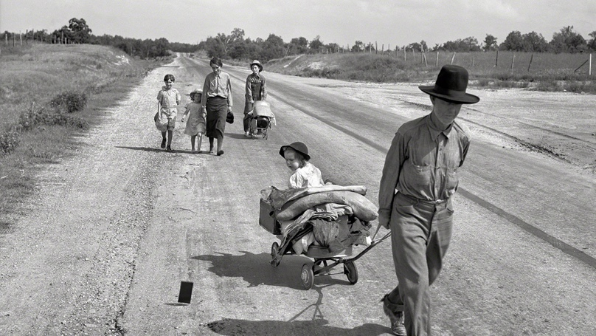
Americans meanwhile feared foreign workers willing to work for even lower wages. The Saturday Evening Post warned that foreign immigrants, who were “compelled to accept employment on any terms and conditions offered,” would exacerbate the economic crisis.31 Exclusionary measures hit Mexican immigrants particularly hard. The State Department made a concerted effort to reduce immigration from Mexico as early as 1929, and Hoover’s executive actions arrived the following year. Officials in the Southwest led a coordinated effort to push out Mexican immigrants. In Los Angeles, the Citizens Committee on Coordination of Unemployment Relief began working closely with federal officials in early 1931 to conduct deportation raids, while the Los Angeles County Department of Charities began a simultaneous drive to repatriate Mexicans and Mexican Americans on relief, negotiating a charity rate with the railroads to return Mexicans “voluntarily” to their mother country. According to the federal census, from 1930 to 1940 the Mexican-born population living in Arizona, California, New Mexico, and Texas fell from 616,998 to 377,433. Franklin Roosevelt did not indulge anti-immigrant sentiment as willingly as Hoover had. Under the New Deal, the Immigration and Naturalization Service halted some of the Hoover administration’s most divisive practices, but with jobs suddenly scarce, hostile attitudes intensified, and official policies less than welcoming, immigration plummeted and deportations rose. Over the course of the Depression, more people left the United States than entered it.33
President Franklin D. Roosevelt, elected in 1932, proposed jobs programs, public work projects, higher wages, shorter hours, old-age pensions, unemployment insurance, farm subsidies, banking regulations, and lower tariffs. His rival in 1932, incumbent President Herbert Hoover warned that such a program represented “the total abandonment of every principle upon which this government and the American system is founded.” He warned that it reeked of European communism, and that “the so called new deals would destroy the very foundations of the American system of life.”38 Americans didn’t buy it. Roosevelt crushed Hoover in November. He won more counties than any previous candidate in American history. He spent the months between his election and inauguration–the twentieth amendment, ratified in 1933, would subsequently move the inauguration from March 4 to January 20–traveling, planning, and assembling a team of advisors, the famous Brain Trust of academics and experts, to help him formulate a plan of attack. On March 4, 1933, in his first inaugural address, Roosevelt famously declared, “This great Nation will endure as it has endured, will revive and will prosper. So, first of all, let me assert my firm belief that the only thing we have to fear is fear itself—nameless, unreasoning, unjustified terror which paralyzes needed efforts to convert retreat into advance.”39
Stabilizing the banks was only a first step. In the remainder of his First Hundred Days, Roosevelt and his congressional allies focused especially on relief for suffering Americans.42 Congress debated, amended, and passed what Roosevelt proposed. As one historian noted, the president “directed the entire operation like a seasoned field general.”43 And despite some questions over the constitutionality of many of his actions, Americans and their congressional representatives conceded that the crisis demanded swift and immediate action. The Civilian Conservation Corps (CCC) employed young men on conservation and reforestation projects; the Federal Emergency Relief Administration (FERA) provided direct cash assistance to state relief agencies struggling to care for the unemployed;44 the Tennessee Valley Authority (TVA) built a series of hydroelectric dams along the Tennessee River as part of a comprehensive program to economically develop a chronically depressed region;45 and several agencies helped home and farm owners refinance their mortgages. And Roosevelt wasn’t done.
The heart of Roosevelt’s early recovery program consisted of two massive efforts to stabilize and coordinate the American economy: the Agricultural Adjustment Administration (AAA) and the National Recovery Administration (NRA). The AAA, created in May 1933, aimed to raise the prices of agricultural commodities (and hence farmers’ income) by offering cash incentives to voluntarily limit farm production (decreasing supply, thereby raising prices).46 The National Industrial Recovery Act (NIRA), which created the NRA in June 1933, suspended antitrust laws to allow businesses to establish “codes” that would coordinate prices, regulate production levels, and establish conditions of employment to curtail “cutthroat competition.” In exchange for these exemptions, businesses agreed to provide reasonable wages and hours, end child labor, and allow workers the right to unionize. Participating businesses earned the right to display a placard with the NRA’s Blue Eagle, showing their cooperation in the effort to combat the Great Depression.47
The programs of the First Hundred Days stabilized the American economy and ushered in a robust though imperfect recovery. GDP climbed once more, but even as output increased, unemployment remained stubbornly high. Though the unemployment rate dipped from its high in 1933, when Roosevelt was inaugurated, vast numbers remained out of work. If the economy could not put people back to work, the New Deal would try. The Civil Works Administration (CWA) and, later, the Works Progress Administration (WPA) put unemployed men and women to work on projects designed and proposed by local governments. The Public Works Administration (PWA) provided grants-in-aid to local governments for large infrastructure projects, such as bridges, tunnels, schoolhouses, libraries, and America’s first federal public housing projects. Together, they provided not only tangible projects of immense public good but employment for millions. The New Deal was reshaping much of the nation.48
Also in 1935, hoping to reconstitute some of the protections afforded workers in the now-defunct NRA, Roosevelt worked with Congress to pass the National Labor Relations Act (known as the Wagner Act for its chief sponsor, New York senator Robert Wagner), offering federal legal protection, for the first time, for workers to organize unions. The labor protections extended by Roosevelt’s New Deal were revolutionary. In northern industrial cities, workers responded to worsening conditions by banding together and demanding support for workers’ rights. In 1935, the head of the United Mine Workers, John L. Lewis, took the lead in forming a new national workers’ organization, the Congress of Industrial Organizations (CIO), breaking with the more conservative, craft-oriented AFL. The CIO won a major victory in 1937 when affiliated members in the United Automobile Workers (UAW) struck for recognition and better pay and hours at a General Motors (GM) plant in Flint, Michigan. Launching a “sit-down” strike, the workers remained in the building until management agreed to negotiate. GM recognized the UAW and granted a pay increase. GM’s recognition gave the UAW new legitimacy and unionization spread rapidly across the auto industry. Across the country, unions and workers took advantage of the New Deal’s protections to organize and win major concessions from employers. Three years after the NLRA, Congress passed the Fair Labor Standards Act, creating the modern minimum wage.
Despite a concerted effort to appoint Black advisors to some New Deal programs, Franklin Roosevelt did little to specifically address the particular difficulties Black communities faced. To do so openly would provoke southern Democrats and put his New Deal coalition—–the uneasy alliance of national liberals, urban laborers, farm workers, and southern whites—at risk. Roosevelt not only rejected such proposals as abolishing the poll tax and declaring lynching a federal crime, he refused to specifically target African American needs in any of his larger relief and reform packages. As he explained to the national secretary of the NAACP, “I just can’t take that risk.”63
In fact, many of the programs of the New Deal had made hard times more difficult. When the codes of the NRA set new pay scales, they usually took into account regional differentiation and historical data. In the South, where African Americans had long suffered unequal pay, the new codes simply perpetuated that inequality. The codes also exempted those involved in farm work and domestic labor, the occupations of a majority of southern Black men and women. The AAA was equally problematic as owners displaced Black tenants and sharecroppers, many of whom were forced to return to their farms as low-paid day labor or to migrate to cities looking for wage work.64
Perhaps the most notorious failure of the New Deal to aid African Americans came with the passage of the Social Security Act. Southern politicians chafed at the prospect of African Americans benefiting from federally sponsored social welfare, afraid that economic security would allow Black southerners to escape the cycle of poverty that kept them tied to the land as cheap, exploitable farm laborers. The Jackson (Mississippi) Daily News callously warned that “The average Mississippian can’t imagine himself chipping in to pay pensions for able-bodied Negroes to sit around in idleness . . . while cotton and corn crops are crying for workers.” Roosevelt agreed to remove domestic workers and farm laborers from the provisions of the bill, excluding many African Americans, already laboring under the strictures of legal racial discrimination, from the benefits of an expanding economic safety net.65
Women, too, failed to receive the full benefits of New Deal programs. On one hand, Roosevelt included women in key positions within his administration, including the first female cabinet secretary, Frances Perkins, and a prominently placed African American advisor in the National Youth Administration, Mary McLeod Bethune. First Lady Eleanor Roosevelt was a key advisor to the president and became a major voice for economic and racial justice. But many New Deal programs were built on the assumption that men would serve as breadwinners and women as mothers, homemakers, and consumers. New Deal programs aimed to help both but usually by forcing such gendered assumptions, making it difficult for women to attain economic autonomy. New Deal social welfare programs tended to funnel women into means-tested, state-administered relief programs while reserving entitlement benefits for male workers, creating a kind of two-tiered social welfare state. And so, despite great advances, the New Deal failed to challenge core inequalities that continued to mark life in the United States.66

