The Rise of Industrial Labor in Antebellum America
More than five million immigrants arrived in the United States between 1820 and 1860. Irish, German, and Jewish immigrants sought new lives and economic opportunities. By the Civil War, nearly one out of every eight Americans had been born outside the United States. A series of push and pull factors drew immigrants to the United States.
In England, an economic slump prompted Parliament to modernize British agriculture by revoking common land rights for Irish farmers. These policies generally targeted Catholics in the southern counties of Ireland and motivated many to seek greater opportunity elsewhere. The booming American economy pulled Irish immigrants toward ports along the eastern United States. Between 1820 and 1840, over 250,000 Irish immigrants arrived in the United States.44 Without the capital and skills required to purchase and operate farms, Irish immigrants settled primarily in northeastern cities and towns and performed unskilled work. Irish men usually emigrated alone and, when possible, practiced what became known as chain migration. Chain migration allowed Irish men to send portions of their wages home, which would then be used either to support their families in Ireland or to purchase tickets for relatives to come to the United States. Irish immigration followed this pattern into the 1840s and 1850s, when the infamous Irish Famine sparked a massive exodus out of Ireland. Between 1840 and 1860, 1.7 million Irish fled starvation and the oppressive English policies that accompanied it.45 As they entered manual, unskilled labor positions in urban America’s dirtiest and most dangerous occupations, Irish workers in northern cities were compared to African Americans, and anti-immigrant newspapers portrayed them with apelike features. Despite hostility, Irish immigrants retained their social, cultural, and religious beliefs and left an indelible mark on American culture.
The sudden influx of immigration triggered a backlash among many native-born Anglo-Protestant Americans. This nativist movement, especially fearful of the growing Catholic presence, sought to limit European immigration and prevent Catholics from establishing churches and other institutions. Popular in northern cities such as Boston, Chicago, Philadelphia, and other cities with large Catholic populations, nativism even spawned its own political party in the 1850s. The American Party, more commonly known as the Know-Nothing Party, found success in local and state elections throughout the North. The party even nominated candidates for president in 1852 and 1856. The rapid rise of the Know-Nothings, reflecting widespread anti-Catholic and anti-immigrant sentiment, slowed European immigration. Immigration declined precipitously after 1855 as nativism, the Crimean War, and improving economic conditions in Europe discouraged potential migrants from traveling to the United States. Only after the American Civil War would immigration levels match and eventually surpass the levels seen in the 1840s and 1850s.
In industrial northern cities, Irish immigrants swelled the ranks of the working class and quickly encountered the politics of industrial labor. Many workers formed trade unions during the early republic. Organizations such as Philadelphia’s Federal Society of Journeymen Cordwainers or the Carpenters’ Union of Boston operated within specific industries in major American cities. These unions worked to protect the economic power of their members by creating closed shops—workplaces wherein employers could only hire union members—and striking to improve working conditions. Political leaders denounced these organizations as unlawful combinations and conspiracies to promote the narrow self-interest of workers above the rights of property holders and the interests of the common good. Unions did not become legally acceptable until 1842 when the Massachusetts Supreme Judicial Court ruled in favor of a union organized among Boston bootmakers, arguing that the workers were capable of acting “in such a manner as best to subserve their own interests.”47 Even after the case, unions remained in a precarious legal position.
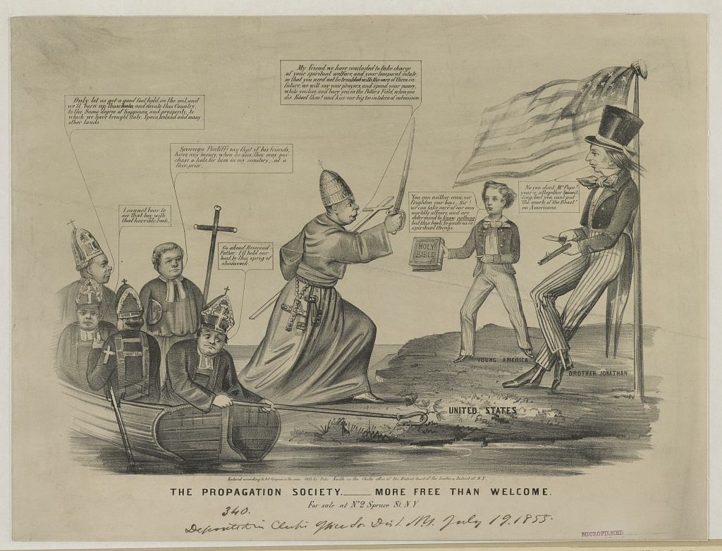
This anti-Catholic print depicts Catholic priests arriving by boat and then threatening Uncle Sam and a young Protestant boy who holds out a Bible in resistance. An anti-Catholic cartoon, reflecting the nativist perception of the threat posed by the Roman Church’s influence in the United States through Irish immigration and Catholic education. N. Currier, “The Propagation Society, More Free than Welcome,” 1855. Library of Congress.

Samuel Morse Fears a Catholic Conspiracy, 1835
Irish immigrants in the early nineteenth century filled jobs created by the Market Revolution. Their arrival provided an important source of labor for a growing economy, but many Americans worried about the influence of these arrivals. Samuel Morse, an inventor who contributed to the development of the telegraph and Morse Code, feared that Irish immigrants represented the front line of a Catholic conspiracy to destroy the United States.

That a vigorous and unexampled effort is making by the despotic governments of Europe to cause Popery to overspread this country, is a fact too palpable to be contradicted. Did not official documents lately published, put this fact beyond dispute, yet the writer had personal evidence sufficient to convince him of the fact and of the political object of the enterprise, while residing in Italy in the years 1830-31, from conversations with nobles and gentlemen of different countries, with the officers of various foreign governments, visiting and resident in the Roman and Austrian states, and with priests and other ecclesiastics of the Roman faith. Sometimes it was hinted to him as a check to too sanguine anticipations of the triumph of the experiment of our democratic republican government; sometimes it was told him by the former class in a tone of exultation that a cause was in operation which would surely overthrow our institutions and gradually bring us under a form of government less obnoxious to the pride, and less dangerous to the existence, of the antiquated despotic systems of Europe. In addition to these hints to the writer, concerning the efforts making by the governments of Europe to carry Popery through all our borders, other American travellers will testify to similar hints made to them. By one I am permitted to say, that the celebrated naturalist, the late Baron Cuvier, known also as a zealous Protestant, inquired of him with marks of concern, if it were indeed true that Popery had made such progress in the United States, as to cause the exultation (which it seems was no secret) among the legitimates of Europe. And again, that a distinguished member of one of the Protestant German embassies, in Rome also made similar inquiries of him, having heard much boasting of the progress of Popery in the United States, adding this pertinent remark, “they will be hammer or nails, Sir, they will persecute, or be persecuted.” These facts may be of so much importance in aid of the other proofs of a conspiracy which these numbers unfold, as to show that among the various higher classes of Europe the enterprise of a Popish crusade in this country is not only a subject of notoriety, but is viewed with great interest, and is considered as having a most important political bearing…
Mistrust of all that Popery does, or affects to do, whether as a friend or foe in any part of the country, is the only feeling that true charity, universal charity, allows us to indulge….
Every account from Europe attests the correctness of the views here taken more than a year since, of the political state of the civilized world. This war of opinions, or of categories, as Lafayette termed it, is in truth commenced, and Americans, if they will but use common observation, cannot but feel that a neglect to notice, and provide against the consequences of that settled, systematic hostility to free institutions so strongly manifested by foreign powers, and which is daily assuming a more serious aspect, will inevitably result in mischief to the country, will surely be attended with anarchy if they wake not to the apprehension of the reality of this danger. Americans, you indeed sleep upon a mine. This is scarcely a figure of speech; you have excitable materials in the bosom of your society, which, skillfully put in action by artful demagogues, will subvert your present social system; you have a foreign interest too, daily, hourly, increasing, ready to take advantage of every excitement, and which will shortly be beyond your control, or will be subdued only by blood. You have agents among you, men in the pay of those very foreign powers, whose every measure of foreign and domestic policy has now for its end and aim the destruction of liberty every where. To increase your peril, you have a press that will not apprise you of the dangers that threaten you; we can reach you with our warnings only through the religious journals ; the daily press is blind, or asleep, or bribed, or afraid; at any rate, it is silent on this subject, and thus is throwing the weight of its influence on the side of your enemies. Foreign spies have clothed themselves in a religious dress, and so awe-struck are our journalists at its sacred texture, or so unable or unwilling to discern the difference between the man and his mask, that they start away in fear, lest they should be called bigoted or intolerant, or persecuting, if they should venture to lift up the consecrated cloak that hides a foreign foe. Americans, if you depend on your daily press, you rely on a broken reed; it fails you in your need. It dare not, no, it dare not attack Popery. It dare not drag into the light the political enemies of your liberty, because they come in the name of religion. All despotic Europe is awake and active in plotting your downfall, and yet they let you sleep, and you choose not to be awaked; “a little more sleep, a little more slumber, a little more folding of the hands to sleep.” And now like a man whose house is on fire, dreaming of comfort and security, you will perhaps repel with passion and reproach the friendly hand that would wake you in season to escape with your life.

Samuel Morse, Foreign Conspiracy Against the Liberties of the United States (New York: 1835), 16-18,

Texas, Mexico and the United States
After gaining its independence from Spain in 1821, Mexico hoped to attract new settlers to its northern areas to create a buffer between it and the powerful Comanche. New immigrants, mostly from the southern United States, poured into Mexican Texas. Over the next twenty-five years, concerns over growing Anglo influence and possible American designs on the area produced great friction between Mexicans and the former Americans in the area. In 1829, Mexico, hoping to quell both anger and immigration, outlawed slavery and required all new immigrants to convert to Catholicism. American immigrants, eager to expand their agricultural fortunes, largely ignored these requirements. In response, Mexican authorities closed their territory to any new immigration in 1830—a prohibition ignored by Americans who often squatted on public lands.28
In 1834, an internal conflict between federalists and centralists in the Mexican government led to the political ascendency of General Antonio López de Santa Anna. Santa Anna, governing as a dictator, repudiated the federalist Constitution of 1824, pursued a policy of authoritarian central control, and crushed several revolts throughout Mexico. Anglo settlers in Mexican Texas, or Texians as they called themselves, opposed Santa Anna’s centralizing policies and met in November. They issued a statement of purpose that emphasized their commitment to the Constitution of 1824 and declared Texas to be a separate state within Mexico. After the Mexican government angrily rejected the offer, Texian leaders soon abandoned their fight for the Constitution of 1824 and declared independence on March 2, 1836.29 The Texas Revolution of 1835–1836 was a successful secessionist movement in the northern district of the Mexican state of Coahuila y Tejas that resulted in an independent Republic of Texas.
At the Alamo and Goliad, Santa Anna crushed smaller rebel forces and massacred hundreds of Texian prisoners. The Mexican army pursued the retreating Texian army deep into East Texas, spurring a mass panic and evacuation by American civilians known as the Runaway Scrape. The confident Santa Anna consistently failed to make adequate defensive preparations, an oversight that eventually led to a surprise attack from the outnumbered Texian army led by Sam Houston on April 21, 1836. The battle of San Jacinto lasted only eighteen minutes and resulted in a decisive victory for the Texians, who retaliated for previous Mexican atrocities by killing fleeing and surrendering Mexican soldiers for hours after the initial assault. Santa Anna was captured in the aftermath and compelled to sign the Treaty of Velasco on May 14, 1836, by which he agreed to withdraw his army from Texas and acknowledged Texas independence. Although a new Mexican government never recognized the Republic of Texas, the United States and several other nations gave the new country diplomatic recognition.30
Texas annexation had remained a political landmine since the Republic declared independence from Mexico in 1836. In the final days of his presidency, President Tyler at last extended an official offer to Texas on March 3, 1845. The republic accepted on July 4, becoming the twenty-eighth state.
Mexico denounced annexation as “an act of aggression, the most unjust which can be found recorded in the annals of modern history.”31 Beyond the anger produced by annexation, the two nations both laid claim over a narrow strip of land between two rivers. Mexico drew the southwestern border of Texas at the Nueces River, but Texans claimed that the border lay roughly 150 miles farther west at the Rio Grande. Neither claim was realistic since the sparsely populated area, known as the Nueces strip, was in fact controlled by Native Americans.
In the early fall of 1846, the U.S. Army invaded Mexico on multiple fronts and within a year’s time General Winfield Scott’s men took control of Mexico City. Peace finally came on February 2, 1848 with the signing of the Treaty of Guadalupe Hidalgo. The United States gained lands that would become the future states of California, Utah, and Nevada; most of Arizona; and parts of New Mexico, Colorado, and Wyoming. Mexican officials would also have to surrender their claims to Texas and recognize the Rio Grande as its southern boundary. The United States offered $15 million for all of it. With American soldiers occupying their capital, Mexican leaders had no choice but to sign.
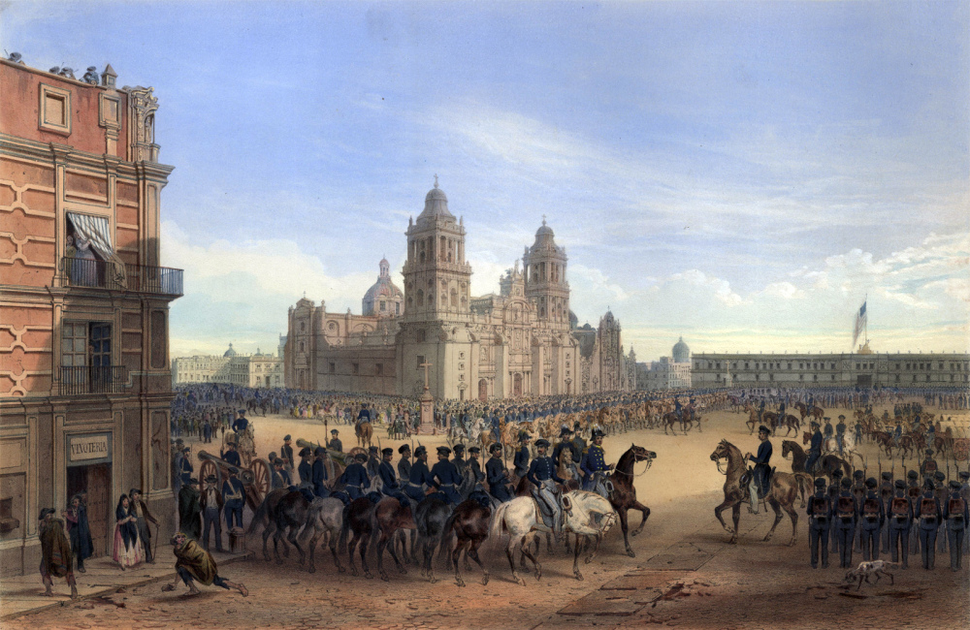
“General Scott’s entrance into Mexico.” Lithograph. 1851. Originally published in George Wilkins Kendall & Carl Nebel, The War between the United States and Mexico Illustrated, Embracing Pictorial Drawings of all the Principal Conflicts (New York: D. Appleton), 1851. Wikimedia Commons

John O’Sullivan Declares America’s Manifest Destiny, 1845
John Louis O’Sullivan, a popular editor and columnist, articulated the long-standing American belief in the God-given mission of the United States to lead the world in the transition to democracy. He called this America’s “manifest destiny.” This idea motivated wars of American expansion. He explained this idea in the following essay where he advocated adding Texas to the United States.
Texas is now ours… Her star and her stripe may already be said to have taken their place in the glorious blazon of our common nationality; and the sweep of our eagle’s wing already includes within its circuit the wide extent of her fair and fertile land. She is no longer to us a mere geographical space–a certain combination of coast, plain, mountain, valley, forest and stream. She is no longer to us a mere country on the map. She comes within the dear and sacred designation of Our Country… other nations have undertaken to intrude themselves … in a spirit of hostile interference against us, for the avowed object of thwarting our policy and hampering our power, limiting our greatness and checking the fulfillment of our manifest destiny to overspread the continent allotted by Providence for the free development of our yearly multiplying millions. This we have seen done by England, our old rival and enemy; and by France, strangely coupled with her against us….
The independence of Texas was complete and absolute. It was an independence, not only in fact, but of right. No obligation of duty towards Mexico tended in the least degree to restrain our right to effect the desired recovery of the fair province once our own–whatever motives of policy might have prompted a more deferential consideration of her feelings and her pride, as involved in the question. If Texas became peopled with an American population; it was by no contrivance of our government, but on the express invitation of that of Mexico herself…
California will, probably, next fall away from the loose adhesion which, in such a country as Mexico, holds a remote province in a slight equivocal kind of dependence on the metropolis. Imbecile and distracted, Mexico never can exert any real governmental authority over such a country. The impotence of the one and the distance of the other, must make the relation one of virtual independence; unless, by stunting the province of all natural growth, and forbidding that immigration which can alone develop its capabilities and fulfil the purposes of its creation, tyranny may retain a military dominion, which is no government in the, legitimate sense of the term. In the case of California this is now impossible. The Anglo-Saxon foot is already on its borders. Already the advance guard of the irresistible army of Anglo-Saxon emigration has begun to pour down upon it, armed with the plough and the rifle, and marking its trail with schools and colleges, courts and representative halls, mills and meeting-houses. A population will soon be in actual occupation of California, over which it will be idle for Mexico to dream of dominion. They will necessarily become independent. All this without agency of our government, without responsibility of our people–in the natural flow of events, the spontaneous working of principles, and the adaptation of the tendencies and wants of the human race to the elemental circumstances in the midst of which they find themselves placed. And they will have a right to independence–to self-government–to the possession of the homes conquered from the wilderness by their own labors and dangers, sufferings and sacrifices-a better and a truer right than the artificial tide of sovereignty in Mexico, a thousand miles distant, inheriting from Spain a title good only against those who have none better. Their right to independence will be the natural right of self-government belonging to any community strong enough to maintain it–distinct in position, origin and character, and free from any mutual obligations of membership of a common political body, binding it to others by the duty of loyalty and compact of public faith.This will be their title to independence; and by this title, there can be no doubt that the population now fast streaming down upon California win both assert and maintain that independence. Whether they will then attach themselves to our Union or not, is not to be predicted with any certainty. Unless the projected railroad across the continent to the Pacific be carried into effect, perhaps they may not; though even in that case, the day is not distant when the Empires of the Atlantic and Pacific would again flow together into one, as soon as their inland border should approach each other. But that great work, colossal as appears the plan on its first suggestion, cannot remain long unbuilt. Its necessity for this very purpose of binding and holding together in its iron clasp our fast-settling Pacific region with that of the Mississippi valley–the natural facility of the route–the ease with which any amount of labor for the construction can be drawn in from the overcrowded populations of Europe, to be paid in die lands made valuable by the progress of the work itself–and its immense utility to the commerce of the world with the whole eastern Asia, alone almost sufficient for the support of such a road–these coast of considerations give assurance that the day cannot be distant which shall witness the conveyance of the representatives from Oregon and California to Washington within less time than a few years ago was devoted to a similar journey by those from Ohio; while the magnetic telegraph will enable the editors of the “San Francisco Union,” the “Astoria Evening Post,” or the “Nootka Morning News,” to set up in type the first half of the President’s Inaugural before the echoes of the latter half shall have died away beneath the lofty porch of the Capitol, as spoken from his lips.

V. Manifest Destiny and the Gold Rush
California, belonging to Mexico prior to the war, was at least three arduous months’ travel from the nearest American settlements. There was some sparse settlement in the Sacramento Valley, and missionaries made the trip occasionally. The fertile farmland of Oregon. Dramatized stories of Native American attacks filled migrants with a sense of foreboding, although most settlers encountered no violence and often no Native Americans at all. The slow progress, disease, human and oxen starvation, poor trails, terrible geographic preparations, lack of guidebooks, threatening wildlife, vagaries of weather, and general confusion were all more formidable and frequent than attacks from Native Americans. Despite the harshness of the journey, by 1848 approximately twenty thousand Americans were living west of the Rockies, with about three fourths of that number in Oregon.
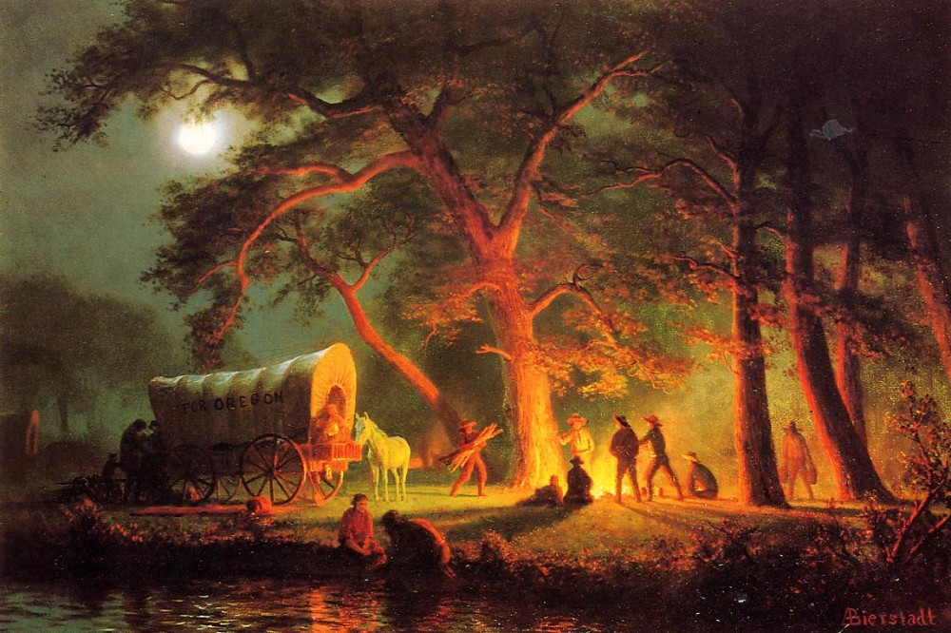
The great environmental and economic potential of the Oregon Territory led many to pack up their families and head west along the Oregon Trail. The Trail represented the hopes of many for a better life, represented and reinforced by images like Bierstadt’s idealistic Oregon Trail. Albert Bierstadt, Oregon Trail (Campfire), 1863. Wikimedia.

On January 24, 1848, James W. Marshall, a contractor hired by John Sutter, discovered gold on Sutter’s sawmill land in the Sacramento Valley area of the California Territory. Most western settlers sought land ownership, but the lure of getting rich quick drew younger single men (with some women) to gold towns throughout the West. These adventurers and fortune-seekers then served as magnets for the arrival of others providing services associated with the gold rush. Towns and cities grew rapidly throughout the West, notably San Francisco, whose population grew from about five hundred in 1848 to almost fifty thousand by 1853.

By the end of the 1850s, Chinese and Mexican immigrants made up one fifth of the mining population in California. The ethnic patchwork of these frontier towns belied a clearly defined socioeconomic arrangement that saw whites on top as landowners and managers, with poor whites and ethnic minorities working the mines and assorted jobs. The competition for land, resources, and riches furthered individual and collective abuses, particularly against Native Americans and older Mexican communities. California’s towns, as well as those dotting the landscape throughout the West, struggled to balance security with economic development and the protection of civil rights and liberties.
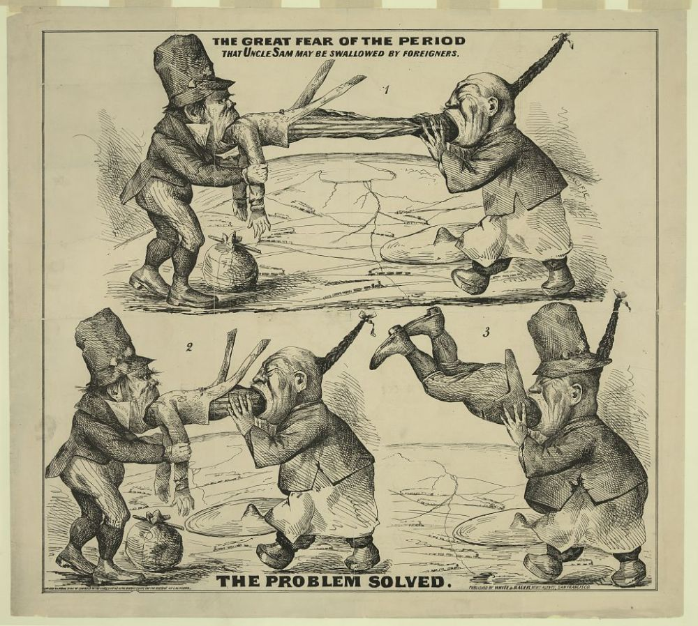
This cartoon depicts a highly racialized image of a Chinese immigrant and Irish immigrant “swallowing” the United States–in the form of Uncle Sam. Networks of railroads and the promise of American expansion can be seen in the background. “The great fear of the period That Uncle Sam may be swallowed by foreigners : The problem solved,” 1860-1869. Library of Congress.

Chinese Merchant Complains of Racist Abuse, 1860
The California Gold Rush of 1849 brought a major influx of Asian immigrants to the new state. This number only grew after railroad companies turned to Chinese laborers to build western railroads. Life for these immigrants was particularly difficult, as even financially successful Chinese immigrants faced considerable discrimination. In 1860, the Chinese merchant Pun Chi drafted this petition to congress, calling on the legislature to do more to protect Chinese immigrants.
We are natives of the empire of China, each following some employment or profession–literary men, farmers, mechanics or merchants. When your honorable government threw open the territory of California, the people of other lands were welcomed here to search for gold and to engage in trade. The ship-masters of your respected nation came over to our country, lauded the equality of your laws, extolled the beauty of your manners and customs, and made it known that your officers and people were extremely cordial toward the Chinese. Knowing well the harmony which had existed between our respective governments, we trusted in your sincerity. Not deterred by the long voyage, we came here presuming that our arrival would be hailed with cordiality and favor. But, alas! what times are these!–when former kind relations are forgotten, when we Chinese are viewed like thieves and enemies, when in the administration of justice our testimony is not received, when in the legal collection of the licenses we are injured and plundered, and villains of other nations are encouraged to rob and do violence to us! Our numberless wrongs it is most painful even to recite. At the present time, if we desire to quit the country, we are not possessed of the pecuniary means; if allowed to remain, we dread future troubles. But yet, on the other hand, it is our presumption that the conduct of the officers of justice here has been influenced by temporary prejudices and that your honorable government will surely not uphold their acts. We are sustained by the confidence that t-589he benevolence of your eminent body, contemplating the people of the whole world as one family, will most assuredly not permit the Chinese population without guilt to endure injuries to so cruel a degree. We would therefore present the following twelve subjects for consideration at your bar. We earnestly pray that you would investigate and weigh them; that you would issue instructions to your authorities in each State that they shall cast away their partial and unjust practices, restore tranquillity to us strangers, and that you would determine whether we are to leave the country or to remain. Then we will endure ensuing calamities without repining, and will cherish for you sincere gratitude and most profound respect.
… The class that engage in digging gold are, as a whole, poor people. We go on board the ships. There we find ourselves unaccustomed to winds and waves and to the extremes of heat and cold. We eat little; we grieve much. Our appearance is plain and our clothing poor. At once, when we leave the vessel, boatmen extort heavy fares; all kinds of conveyances require from us more than the usual charges; as we go on our way we are pushed and kicked and struck by the drunken and the brutal; but as we cannot speak your language, we bear our injuries and pass on. Even when within doors, rude boys throw sand and bad men stones after us. Passers by, instead of preventing these provocations, add to them by their laughter. We go up to the mines; there the collectors of the licenses make unlawful exactions and robbers strip, plunder, wound and even murder some of us. Thus we are plunged into endless uncommiserated wrongs. But the first root of them all is that very degradation and contempt of the Chinese as a race of which we have spoken, which begins with your honorable nation, but which they communicate to people from other countries, who carry it to greater lengths.
Now what injury have we Chinese done to your honorable people that they should thus turn upon us and make us drink the cup of wrong even to its last poisonous dregs?
… If a Chinese earns a dollar and a half in gold per day, his first desire is to go to an American and buy a mining claim. But should this yield a considerable result, the seller, it is possible, compels him to relinquish it. Perhaps robbers come and strip him of the gold. He dare not resist, since he cannot speak the language, and has not the power to withstand them. On the other hand, those who have no means to buy a claim seek some ground which other miners have dug over and left, and thus obtain a few dimes. From the proceeds of a hard day’s toil, after the pay for food and clothes very little remains. It is hard for them to be prepared to meet the collector when he comes for the license money. If such a one turns his thoughts back to the time when he came here, perhaps he remembers that then he borrowed the money for his passage and expenses from his kindred and friends, or perhaps he sold all his property to obtain it; and how bitter those thoughts are! In the course of four years, out of each ten men that have come over scarcely more than one or two get back again. Among those who cannot do so, the purse is often empty; and the trials of many of them are worthy of deep compassion. Thus it is evident that the gold mines are truly of little advantage to the Chinese. Yet the legislature questions whether it shall not increase the license; that is, increase trouble upon trouble! It is pressing us to death. If it is your will that Chinese shall not dig the gold of your honorable country, then fix a limit as to time, say, for instance, three years, within which every man of them shall provide means to return to his own country. Thus we shall not perish in a foreign land. Thus mutual kindly sentiments shall be restored again…
Pun Chi, “A Remonstrance from the Chinese in California to the Congress of the United States,” in William Speer, The Oldest and the Newest Empire: China and the United States (Pittsburg: 1877), 588-589. 594, 597-598.

